

Deuschle’s Diner

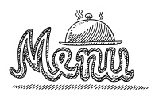

*All fresh Genres all the time!*

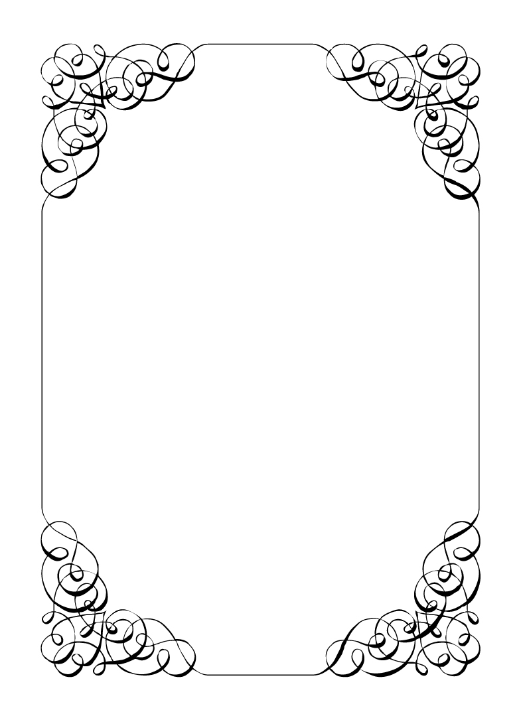

**Fiction**

*Flavorful stories that come from the author’s imagination*

* **Historical Fiction:** based on a person or event from history
* **Science Fiction:** dealing with aliens, the future, or advanced technology
* **Fantasy:** containing monsters, magic or other supernatural elements
* **Realistic Fiction:** a story that could have happened, but didn’t

**Nonfiction**

*Clean, crisp writing that is true or factual*

* **Informational Writing:** provides information on a topic
* **Persuasive Writing:** attempts to influence the reader
* **Autobiography:** the story of one’s life told by oneself
* **Biography:** the story of one’s life told by another

**Drama**

*Saucy writing that is meant to be acted on a stage*

* **Comedy:** has a happy ending
* **Tragedy:**ends in death and sadness

**Poetry**

*Fragrant writing that is concerned with the beauty of language*

**Folklore**

*Slow cooked stories handed down through speech from generation to generation*

* **Fairy Tale:** a story with magic, monsters and/or talking animals
* **Fable:** a very short story that has a moral or life lesson
* **Myth:** has gods/goddesses and often accounts for how things came to be
* **Legend:** an exaggerated story about something that may have been real
* **Tall Tale:** set in the Wild West; the main character’s strengths, skills,

or size have been exaggerated and the tone is funny

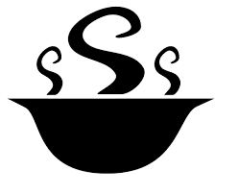

**Genres Cooked to Order** 