Fortune Cookie Fiction
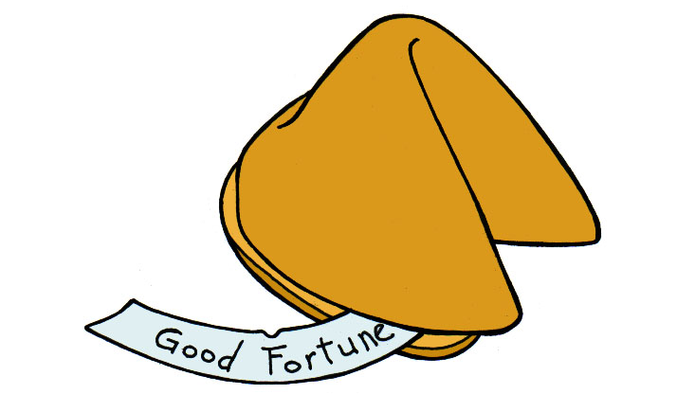
Students struggling with what to read, may pull a fortune cookie from the cookie jar. The fortune slip inside the paper cookie is the Title of a book in the media center.

The only stipulation is that the student must give the book a chance. If they pick a cookie, they are agreeing to check out the book on the fortune slip.

This promotion was very successful!

